Appendix 1: Assignment submission cover sheet

ASSIGNMENT SUBMISSION COVER SHEET

Cse25-390
Student Id:

Student names:
Tshegofatso Patricia Relaeng
Student email:

Cse25-390@thuto.bac.ac.bw
Cohort: cse1-4

WMD Assignment Part A
Assignment title:

18 May 2026
Date of submission:
BSC Computer Systems Engineering

Programme of Study:

2026
Year of Study:

Intellectual property statement
By checking the box below, I certify that this assignment is my own work and is free from plagiarism. I understand that the assignment may be checked for plagiarism by electronic or other means and may be transferred and stored in a database for the purposes of data-matching to help detect plagiarism. The assignment has not previously been submitted for assessment in any other unit or to any other institution. I
have read and understood the Botswana Accountancy College plagiarism guidelines policy.
☐ Agree Signature………T.Relaeng………………………….
Date…18\05\2026……………………………………….
Page 6 of 6

WEBSITE OUTLINE
Panda Paradise is a clothing website offering stylish and high-quality clothing. It is a engaging and user-friendly platform that allows customers to view, explore and purchase products online. Panda Paradise also offers easy navigation, personalized recommendations and convenience for customers by easy accessibility throughout all platforms.
GOALS AND OBJECTIVE
- Promote the brand
The website is created to show brand identity and make it more visible to customers as a reliable fashion brand. This helps to build more trust, attract and encourage customers to support and buy from Panda Paradise.
- Promote sales
The goal is to encourage customers to make purchases using easy online platforms. This will help increase profits and allow the business to continue operating. Panda Paradise making sales will help the business improve and show it is reliable to customers.
- Provide information and ensure accessibility
Panda Paradise website will provide clear information to customers allowing accessible to everyone. Customers will be able to browse through the catalogue and make interaction with the brand at their comfort, anytime and anywhere. Informed decisions can also be made by the brand and customers after feedback from both parties.

TARGET AUDIENCE
- Both genders
- Fashion conscious and people who love trendy and street wear clothing

DEMOGRAPHICS
- Age 12-35
- Gender: Male and Female
- Location: Cities and Towns
- Education: Students and young adults

TECHNICAL APTITUDE
- Customer friendly with ease of access to enable utilization by customers with elementary technical skills.
- Users are comfortable with online shopping websites and can use them.

TYPE OF WEBSITE
The website is a:

Multipage website
That has 9 pages namely:

Log-in(login.html)
Sign-up(signup.html)
Landing page(index.html)
Home(home.html)
About (about.html)
Catalogue(catalogue.html)
Contact(contact.html)
Feedback(feedback.html)
Profile(profile.html)

INFORMATION DESIGN AND TAXONOMY
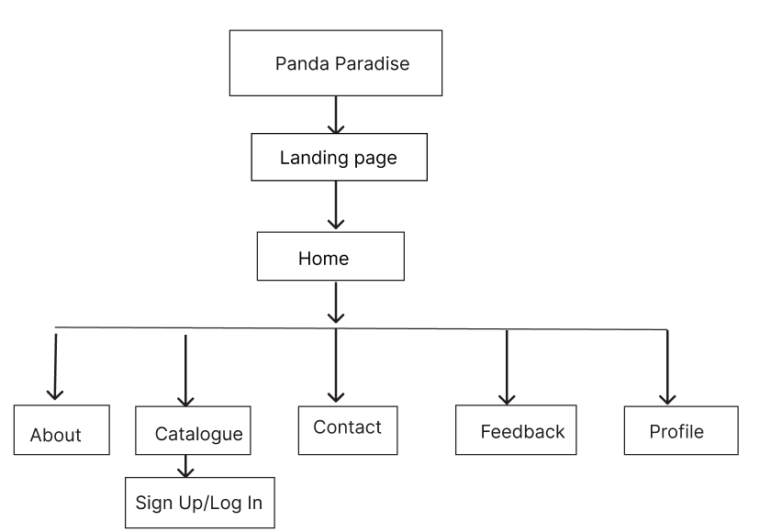

Sign-up: This page will require the customer to input their email address or phone number as well at the password to gain access to the website and utilize it.
Log-in: It will authenticate by prompting users to input their details so that only authorized people can access their accounts.
Landing page: Has the welcoming message and a button called explore which takes the user to the home page.
Home: Has a brief explanation of what the brand offers and a few products which have the option to shop now which leads to catalogue. It also has the services provided by Panda Paradise and the footer containing contact information, location and social media platforms. It also has all navigation.
About: It shows the story of Panda Paradise fully highlighting its mission, vision and values as a brand. Also gives way for customers to explore the fashion collections.
Catalogue: Showcases the products in their categories with full descriptions as well as prices. It also gives customers the path to shop and add products to their cart.
Contact: The page provides customers with information about the website. It also has contact details, location as well as links to the social media platforms of the website.
Feedback: Allows customers to give feedback and review products, helping new users to see and understand the website from other customers’ perspective. This also helps the brand owner to make decisions based on the feedback from customers and improve the brand.
Profile: This is where customers can view their account information and edit their profiles. They can navigate through their order history and manage their preferences

TECHNICAL BRIEF
- Html 5: Is a Markup Language used to structure and create web pages
- CSS: used for typography and appearance for webpages by adding color, fonts and layout
- JavaScript: Used to add functionality and responsiveness to the website
- Bootstrap: has inbuilt CSS and JavaScript that creates responsive websites
- Microsoft Word: The report for the website was done in Microsoft Word.
Tools
- Figma: Used to create designs of websites
- Visual Studio Code: Integrated Development Environment used to write, run and debug code.
- GitHub: Platform used to write, run and store code
- Git Pages: hosts code from repositories and run them into live websites
- Web browsers: Test the website to see if it runs and how it is displayed

PAGE TEMPLATE DESIGN
This is an overview of how Panda Paradise will look like once completed. It includes both high fidelity and low fidelity designs.
LANDING PAGE
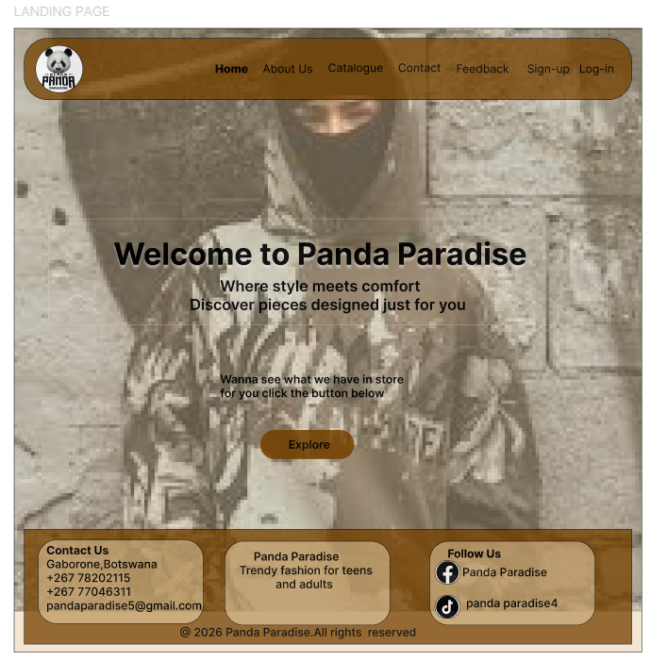
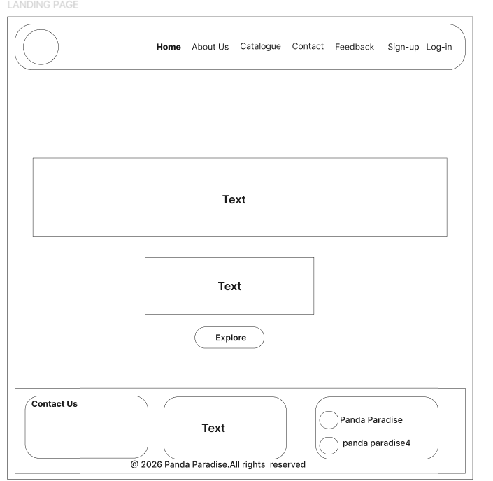
HOME PAGE
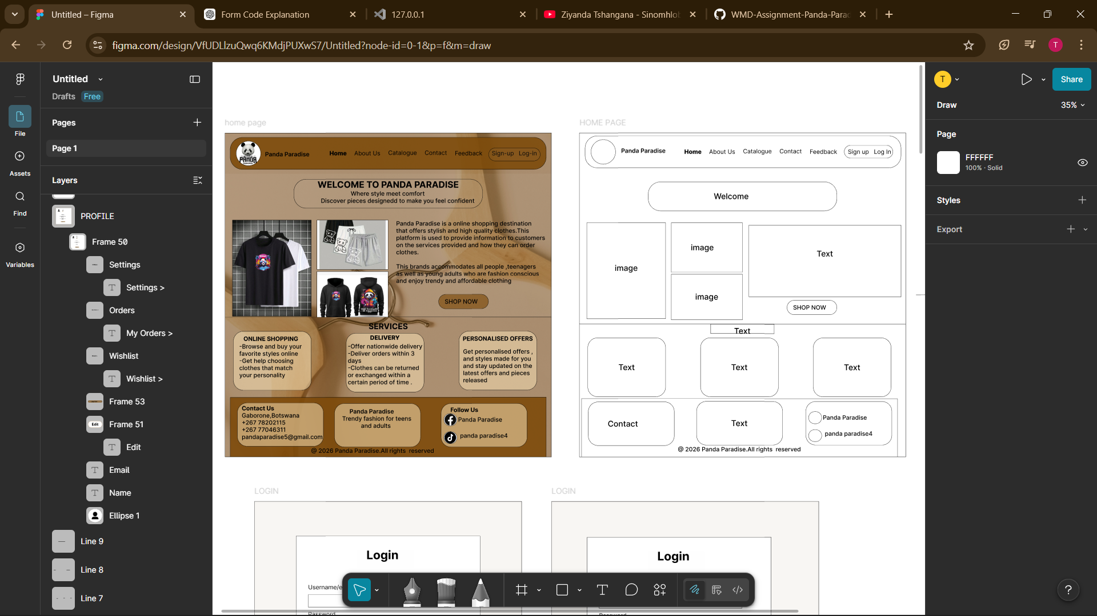

LOGIN
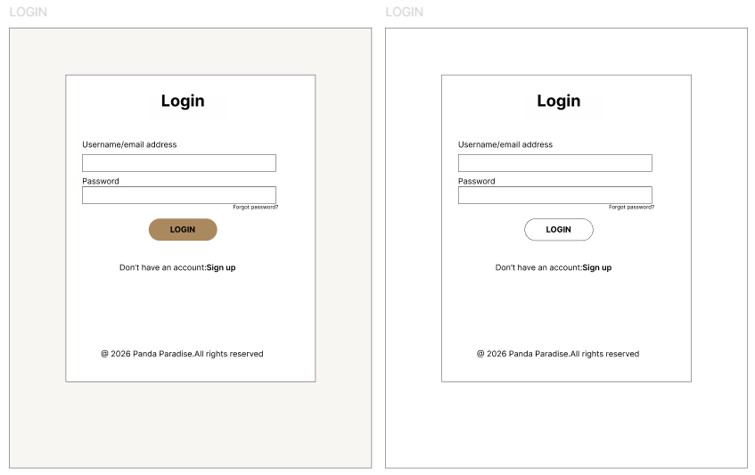
SIGN UP
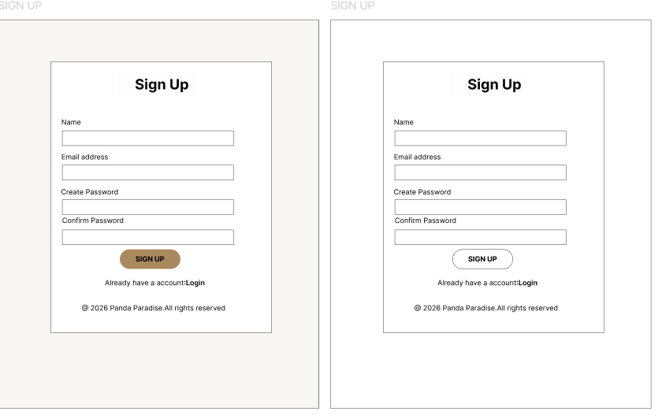

ABOUT US
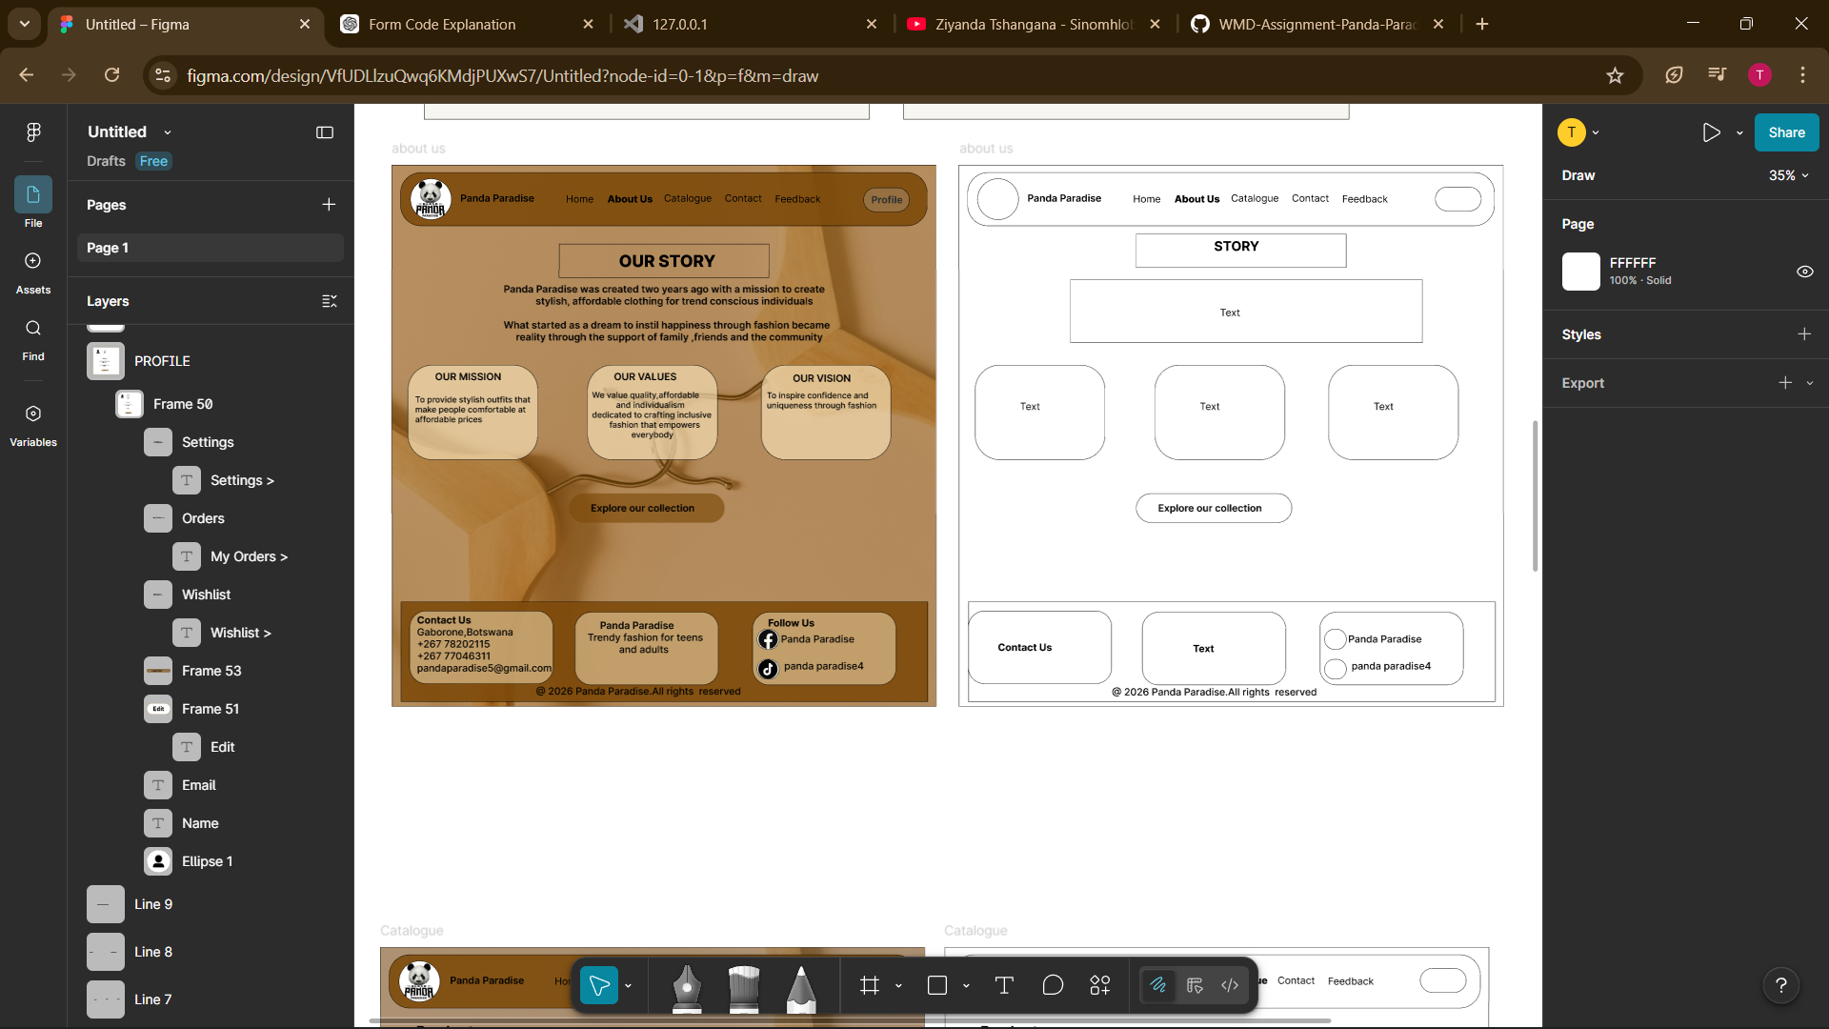
CATALOGUE
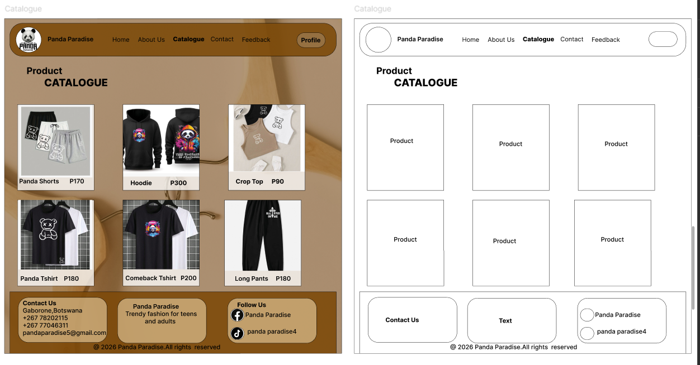

CONTACT
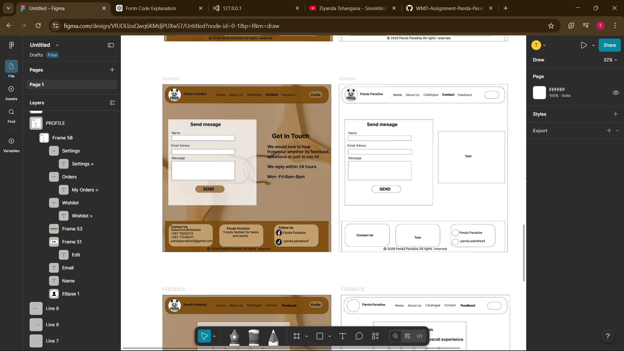

FEEDBACK
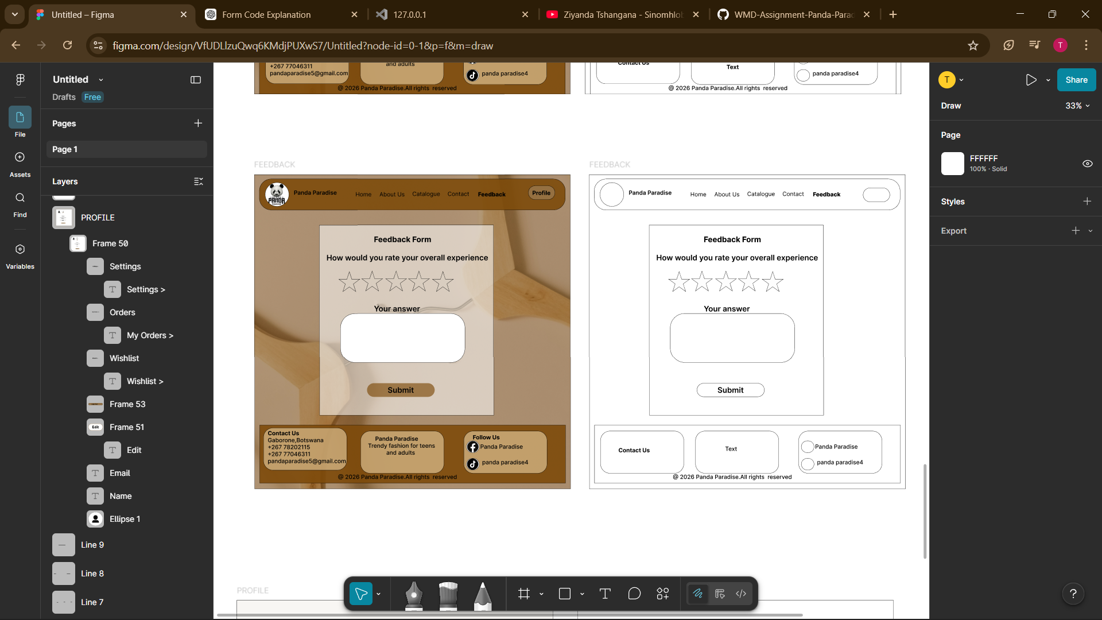

PROFILE
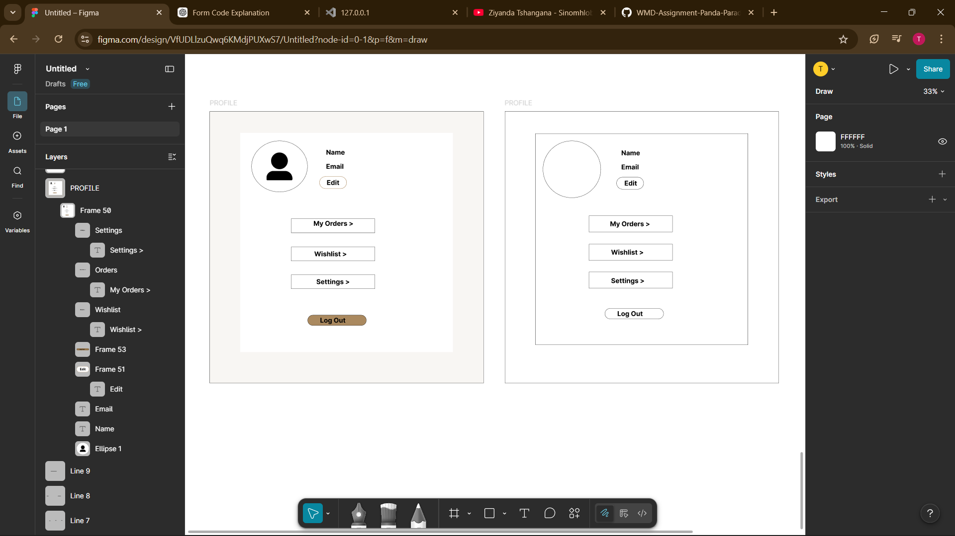

Dev mode link:https://www.figma.com/design/VfUDLlzuQwq6KMdjPUXwS7/Panda-Paradise-Website?node-id=0-1&m=dev&t=PkyrK2YNiy6CkOtg-1
Prototype link:https://www.figma.com/proto/VfUDLlzuQwq6KMdjPUXwS7/Panda-Paradise-Website?node-id=0-1&t=PkyrK2YNiy6CkOtg-1
Structural Layout-HTML 5
These are the semantic elements used to organize and structure a webpage and create websites.
This tag is contained within the head section and sets webpage title Panda Paradise.
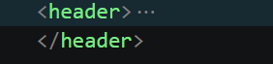
It is the top section of the webpage containing the navigation links, logo as well as the heading.
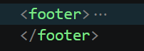
Bottom section of the webpage contains contact information and directory links of the website.
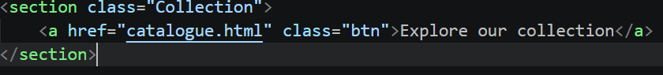
This part groups related content in a website. The section is a class named collection which contains the button “Explore our collection”.
<a href> used to reference and link 2 pages together. It links the button to the html catalogue.
CSS, BOOTSRAP AND JAVASCRIPT
CASCADING STYLE SHEETS: Styles and designs the webpages, controlling the colors, fonts and layouts.
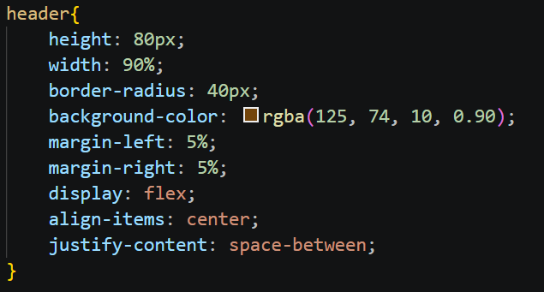
This is a CSS styles block of a header element.
Height: sets the header to 80 pixels
Width: This makes the header take 90% of the page width
Border-radius: This makes the header have rounded corners.
Background-color: sets the color using rgba (red (255), green (255), blue (255) and opacity (0-1)).
Margin-left: This moves the header from the left side of the margin by 5%
Margin-right: This moves the header from the right-side margin by 5% centering the header
Display: The flex lines up contents in the header and arranges item
Align-items: It centers contents within the header
Justify-content: it evenly spaces content within the header section

JAVASCRIPT
Deals with the functionality and reactiveness of the website
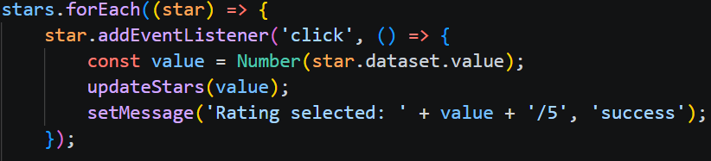
It makes the stars reactive. This block of code is used in a rating system, and it highlights the stars when the user clicks on them. It will display a message that shows the rating was successful. It will display the number of stars selected over the overall rating which is 5.
BOOTSTRAP
A library that contains inbuild CSS and JavaScript to allow for faster responsive of websites
This was used to accommodate small screens to allow the website to adapt well .It creates a hamburger menu button for the navigation, which will expand (“collapse” ) and show the navigation links when clicked.

QUALITY TESTING AND ASSURANCE
Microsoft Edge
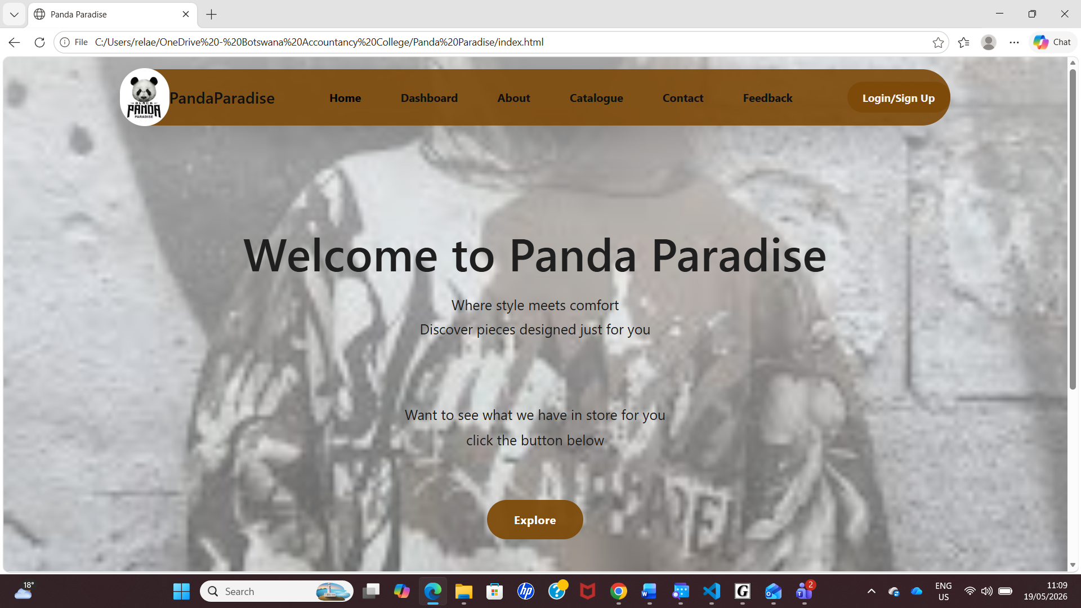
Google Chrome
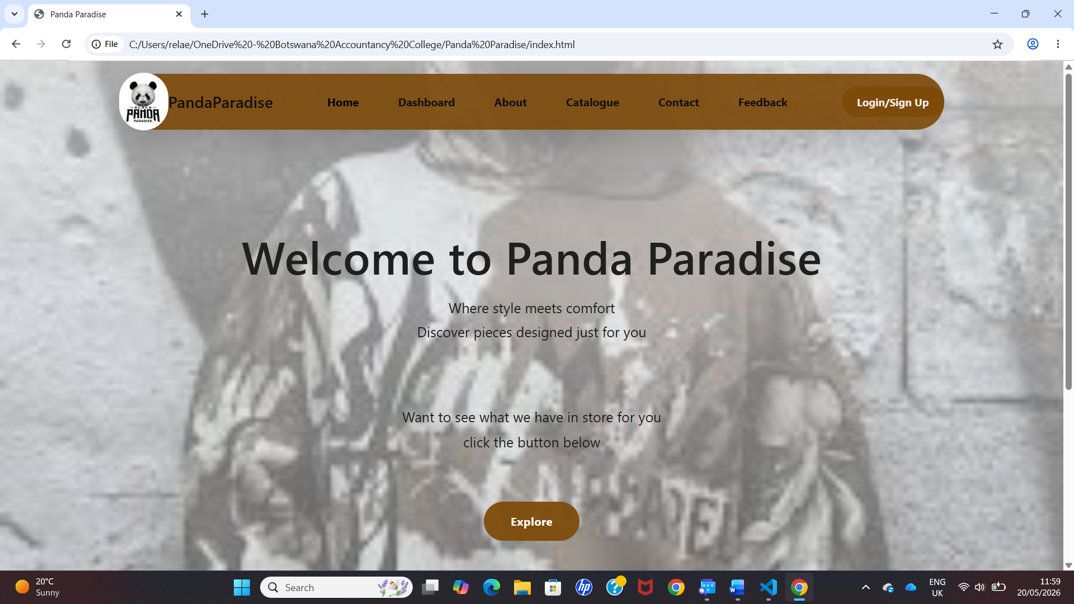

Small Screen
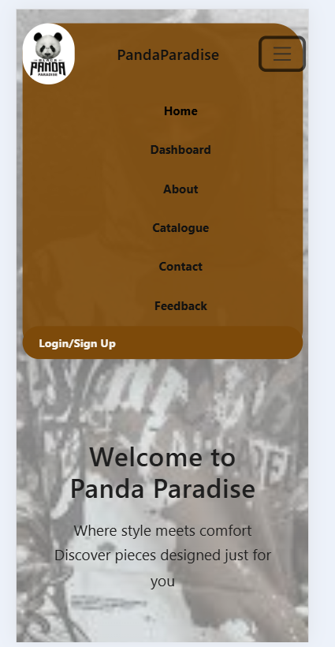
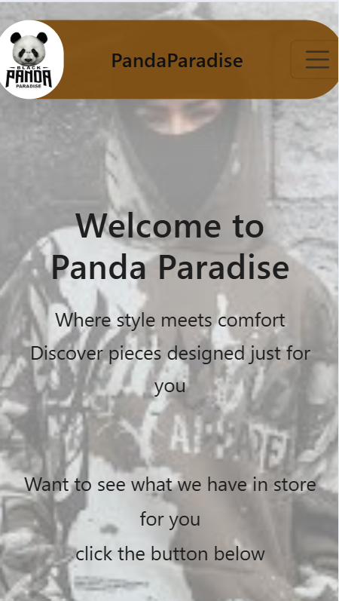

PUBLISHING AND PROMOTION
The website was hosted on GitHub using Git Pages. They are a hosting platform capable of turning any repositories found in GitHub using HTML, CSS, JavaScript and Bootstrap into live websites showcasing in different browsers.
Publishing Process
1.Created GitHub account
2.Created a new repository for the website
3. Used Visual Studio Code to write my code using HTML, CSS, JavaScript and images
4.Uploaded all my files into GitHub using git commands
5.Enabled pages in settings and selected main branch to host the website
LINK: https://cse25-390.github.io/WMD-Assignment-Panda-Paradise-/

Git Commands:
git init
git add .
git commit -m “Panda Paradise”
git branch -M main
git remote add origin https://cse25-390.github.io/WMD-Assignment-Panda-Paradise-/
git push -u origin main
Promotion
- The website link was shared with my lecture and tutor to get feedback on what can be improved.
PROBLEMS ENCOUNTERED DURING DEVELOPNMENT
- Challenge in using CSS, JavaScript and Bootstrap in styling my website and making it responsive
- Fixing multiple errors encountered during the website creation
- Time management
FUTURE DEVELOPMENT /RECOMMENDATIONS
- Adding more interactive features for user experience for example, a search feature for users to access what they need quickly
- Adding more animation and design elements (dark and light mode)
- Making the website user friendly for users with disabilities
- Implement direct payment feature directly on the website using various services.

